**Factor variables**

**1. Creating factor variables**

Factor variables are categorical variables that can be either numeric or string variables. There are a number of advantages to converting categorical variables to factor variables. Perhaps the most important advantage is that they can be used in statistical modeling where they will be implemented correctly, i.e., they will then be assigned the correct number of degrees of freedom. Factor variables are also very useful in many different types of graphics. Furthermore, storing string variables as factor variables is a more efficient use of memory. To create a factor variable we use the **factor** function. The only required argument is a vector of values which can be either string or numeric. Optional arguments include the **levels** argument, which determines the categories of the factor variable, and the default is the sorted list of all the distinct values of the data vector. The **labels** argument is another optional argument which is a vector of values that will be the labels of the categories in the **levels** argument. The **exclude** argument is also optional; it defines which levels will be classified as NA in any output using the factor variable.

First we will generate a vector of numeric data called **schtyp**. It involves the random number generator so we will set the seed to equal 124 in order to make the results reproducible.

set.seed(124)

schtyp <- sample(0:1, 20, replace = TRUE)

schtyp

## [1] 0 0 1 0 0 0 1 0 1 0 1 1 1 1 0 0 1 1 1 0

is.factor(schtyp)

## [1] FALSE

is.numeric(schtyp)

## [1] TRUE

Now let's create a factor variable called **schtyp.f** based on **schtyp**. The first label, private, will correspond to **schtyp**=0 and the second label, public, will correspond to **schtyp**=1 because the order of the labels will follow the numeric order of the data.

schtyp.f <- factor(schtyp, labels = c("private", "public"))

schtyp.f

## [1] private private public private private private public private

## [9] public private public public public public private private

## [17] public public public private

## Levels: private public

is.factor(schtyp.f)

## [1] TRUE

Let's generate a string variable called **ses** (socio-economic status).

ses <- c("low", "middle", "low", "low", "low", "low", "middle", "low",

"middle", "middle", "middle", "middle", "middle", "high", "high",

"low", "middle", "middle", "low", "high")

is.factor(ses)

## [1] FALSE

is.character(ses)

## [1] TRUE

Creating a factor variable **ses.f.bad.order** based on **ses**.

ses.f.bad.order <- factor(ses)

is.factor(ses.f.bad.order)

## [1] TRUE

levels(ses.f.bad.order)

## [1] "high" "low" "middle"

The problem is that the levels are ordered according to the alphabetical order of the categories of **ses**. Thus, "high" is the lowest level of **ses.f.bad.order**, "low" is the middle level and "middle" is the highest level. In order to fix the ordering we need to use the **levels** argument to indicate the correct ordering of the categories. Let's create a new factor variable called **ses.f** with the correct order of categories.

ses.f <- factor(ses, levels = c("low", "middle", "high"))

is.factor(ses.f)

## [1] TRUE

levels(ses.f)

## [1] "low" "middle" "high"

**2. Creating ordered factor variables**

We can create ordered factor variables by using the function **ordered**. This function has the same arguments as the **factor** function. Let's create an ordered factor variable called **ses.order** based on the variable **ses** created in the above example.

ses.order <- ordered(ses, levels = c("low", "middle", "high"))

ses

## [1] "low" "middle" "low" "low" "low" "low" "middle"

## [8] "low" "middle" "middle" "middle" "middle" "middle" "high"

## [15] "high" "low" "middle" "middle" "low" "high"

ses.order

## [1] low middle low low low low middle low middle

## [10] middle middle middle middle high high low middle middle

## [19] low high

## Levels: low < middle < high

is.factor(ses.order)

## [1] TRUE

**3. Adding and dropping levels in factor variables**

Below we will add an element from a new level ("very.high") to **ses.f** our existing factor variable, **ses.f**. The number in the square brackets ( [21] ) indicates the number of the element whose label we wish to change.

ses.f[21] <- "very.high"

**## Warning in `[<-.factor`(`*tmp*`, 21, value = "very.high"): invalid**

**## factor level, NA generated**

ses.f

## [1] low middle low low low low middle low middle

## [10] middle middle middle middle high high low middle middle

## [19] low high <NA>

## Levels: low middle high

We can see that instead of changing from "high" to "very.high", the label was changed from "high" to <NA>. To do this correctly, we need to first add the new level, "very.high", to the factor variable **ses.f** which we do by using the **factor** function with the **levels** argument. Then we can finally add an element to the factor variable from the new level.

ses.f <- factor(ses.f, levels = c(levels(ses.f), "very.high"))

ses.f[21] <- "very.high"

ses.f

## [1] low middle low low low low

## [7] middle low middle middle middle middle

## [13] middle high high low middle middle

## [19] low high very.high

## Levels: low middle high very.high

levels(ses.f)

## [1] "low" "middle" "high" "very.high"

Dropping a level of a factor variable is a little easier. The simplest way is to first remove all the elements within the level to be removed and then to redeclare the variable to be a factor variable. (The level is not automatically removed if there are no elements in it because we could just by chance have a sample which did not contain elements from a specific level.) Let's illustrate this by removing the level of "very.high" from the **ses.f** variable.

ses.f.new <- ses.f[ses.f != "very.high"]

ses.f.new

## [1] low middle low low low low middle low middle

## [10] middle middle middle middle high high low middle middle

## [19] low high

## Levels: low middle high very.high

ses.f.new <- factor(ses.f.new)

ses.f.new

## [1] low middle low low low low middle low middle

## [10] middle middle middle middle high high low middle middle

## [19] low high

## Levels: low middle high

levels(ses.f.new)

## [1] "low" "middle" "high"

**4. Examples of the usefulness of factor variables**

To illustrate the usefulness of factor variables we are first going to create a data frame with all the variables we have used in the previous examples, plus an additional continuous variable called **read** which contains the reading scores. We also redefine **ses.f** to equal the **ses.f.new** variable which does not have any "very.high" elements.

ses.f <- ses.f.new

read <- c(34, 39, 63, 44, 47, 47, 57, 39, 48, 47, 34, 37, 47, 47, 39, 47, 47, 50, 28, 60)

#combining all the variables in a data frame

combo <- data.frame(schtyp, schtyp.f, ses, ses.f, read)

Tables are much easier to interpret when using factor variables because they add useful labels to the table and they arrange the factors in a more understandable order.

table(ses, schtyp)

## schtyp

## ses 0 1

## high 2 1

## low 6 2

## middle 2 7

table(ses.f, schtyp.f)

## schtyp.f

## ses.f private public

## low 6 2

## middle 2 7

## high 2 1

Graphics are another area that benefits from the use of factor variables. As in the tables the factor variable will indicate a better ordering of the graphs as well as add useful labels.

library(lattice)

**## Warning: package 'lattice' was built under R version 3.1.3**

bwplot(schtyp ~ read | ses, data = combo, layout = c(2, 2))

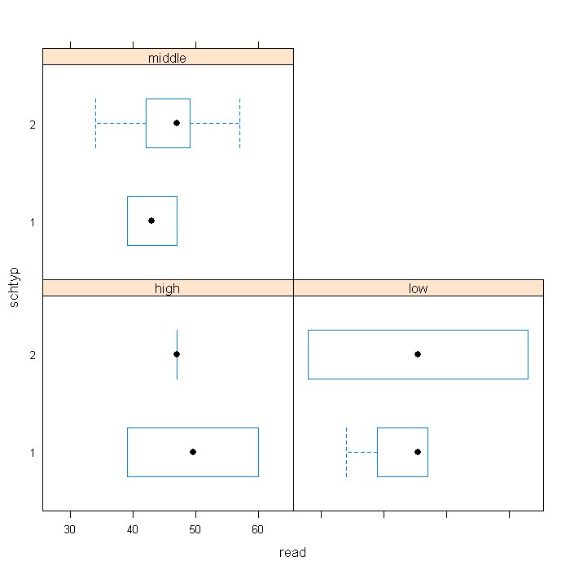

bwplot(schtyp.f ~ read | ses.f, data = combo, layout = c(2, 2))

